BPMN Diagrams
UC01: Create a personal checking account

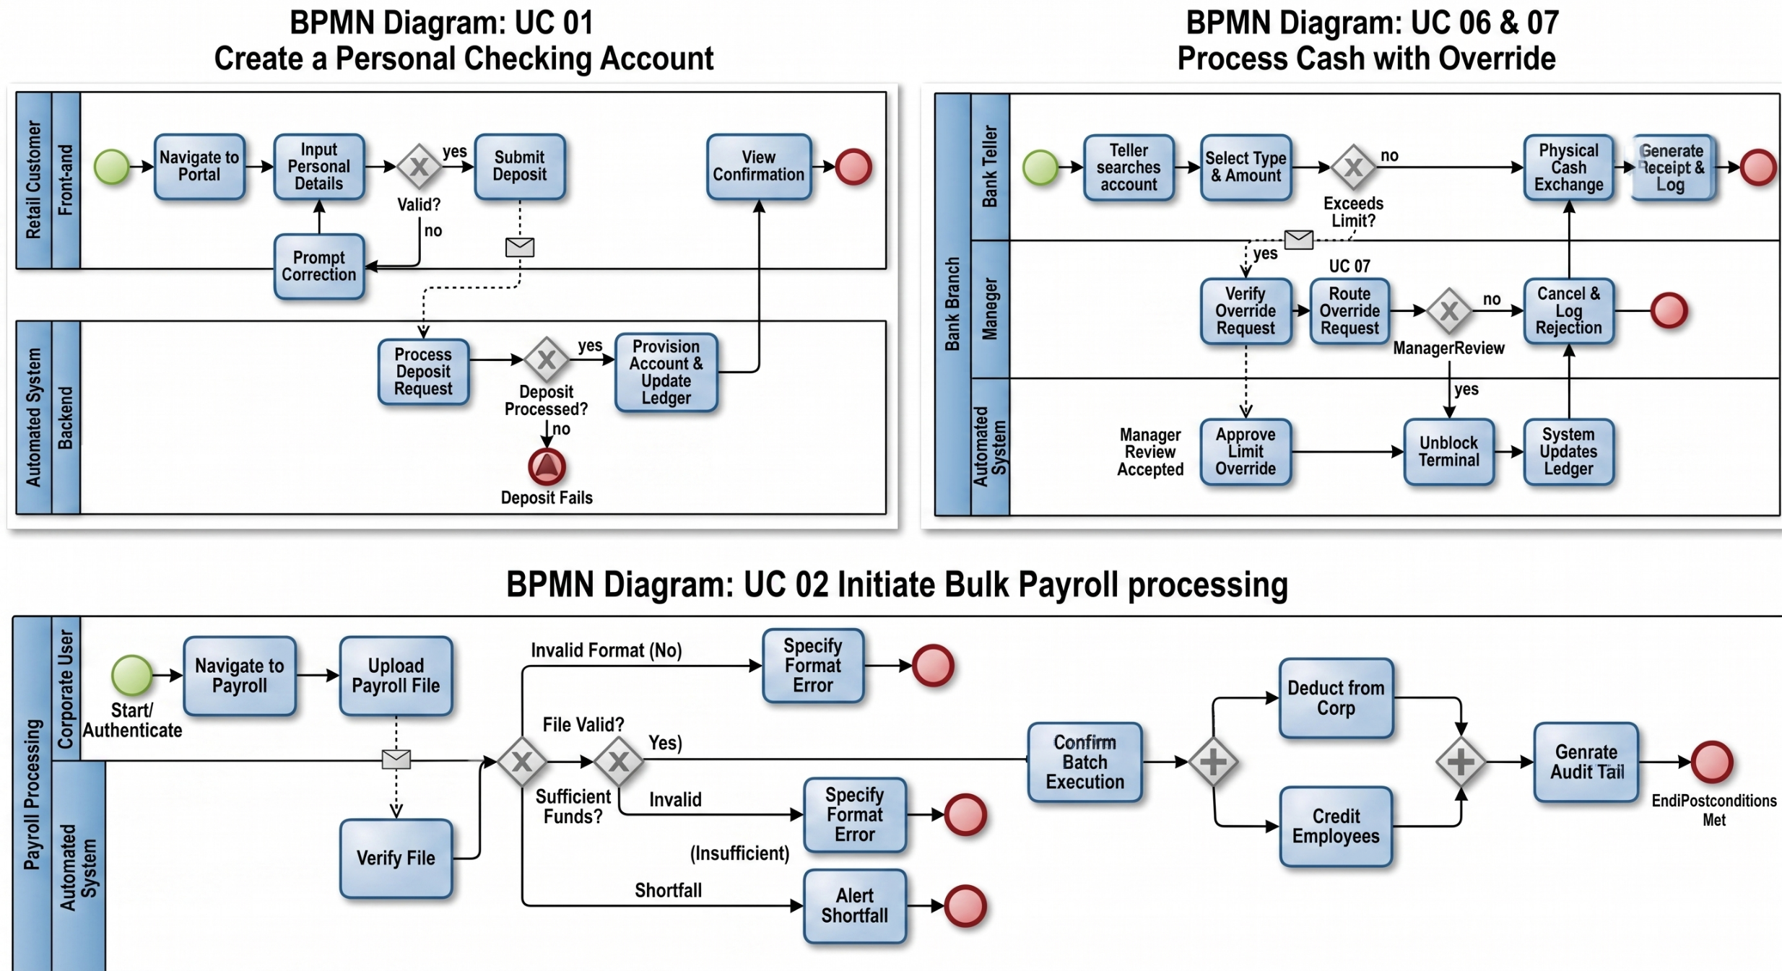
Made by: Erald Saraci

UC02: Initiate Bulk Payroll Processing
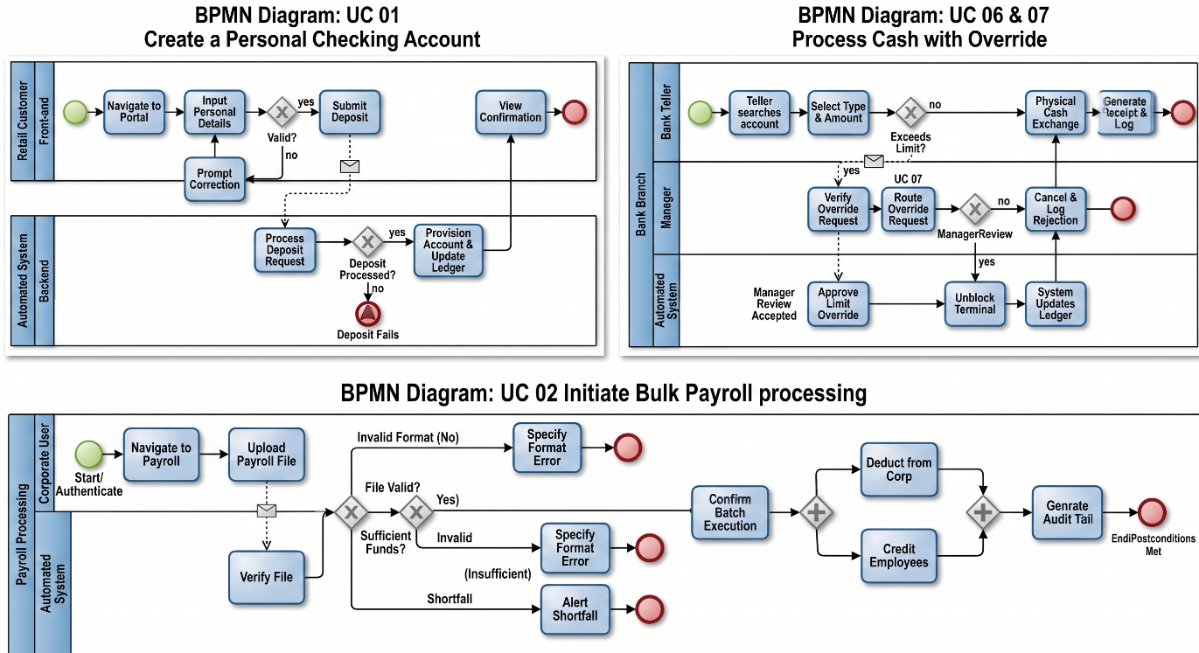
The Power of Parallel (+): A Parallel Gateway means "do both." In an enterprise banking scenario like bulk payroll, the system must execute both database operations concurrently. It deducts the lump sum from the corporation AND distributes the funds to the employees.
The Converging Gateway: The second + gateway right before "Generate Audit Trail" acts as a synchronizer. It tells the system to wait until both the deduction and the crediting are 100% finished before creating the final audit log.This ensures data integrity.
Made by: Aksel Luarasi

UC06 and UC07: Process cash with override

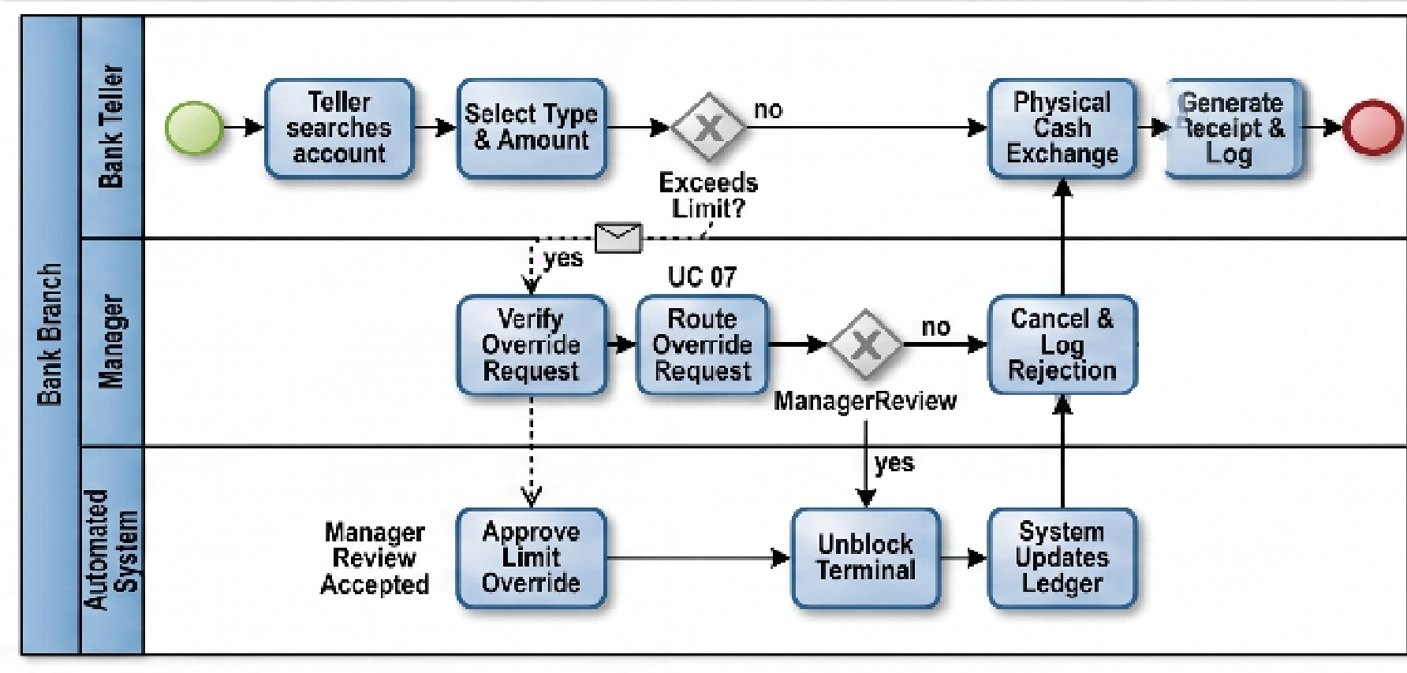
Made by: Denis Robi

